Webinar resources recording: Enabling closed captioning guide.

- Click the play button on the video. You should see three dots ⋮ at the bottom right-hand corner of the screen.
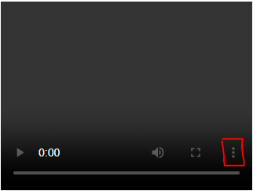

- Click on the three dots. Click on Captions to turn them on.

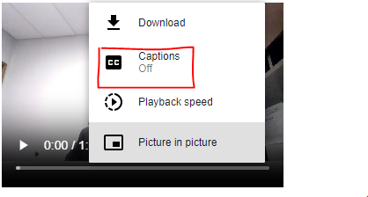

- Return to the video and press play. The captions should now be displayed throughout the video.

